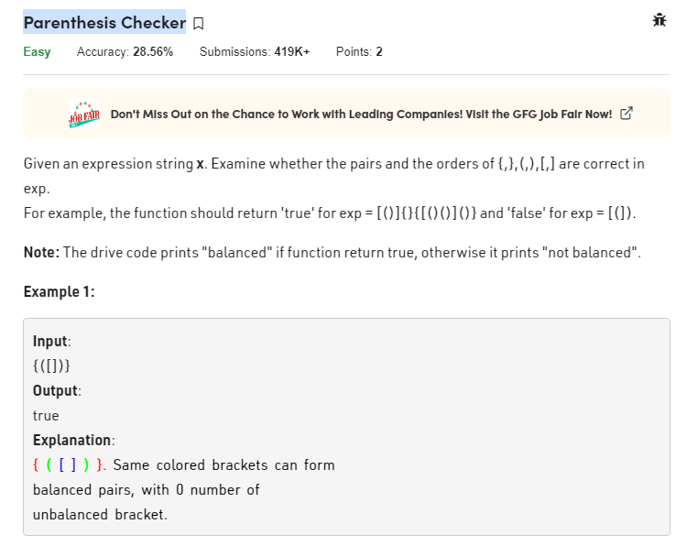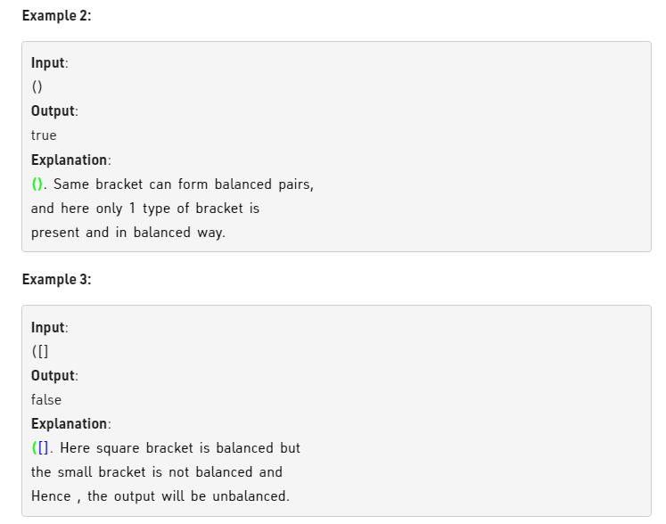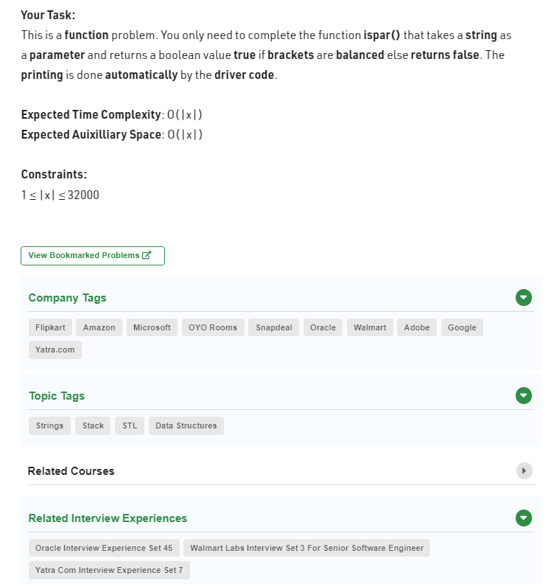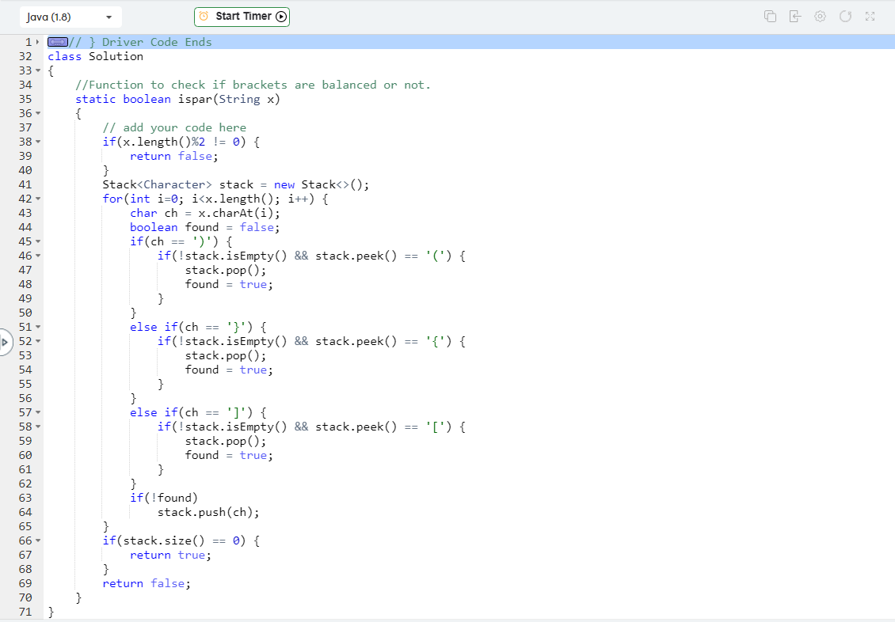

class Solution

{

//Function to check if brackets are balanced or not.

static boolean ispar(String x)

{

// add your code here

if(x.length()%2 != 0) {

return false;

}

Stack<Character> stack = new Stack<>();

for(int i=0; i<x.length(); i++) {

char ch = x.charAt(i);

boolean found = false;

if(ch == ')') {

if(!stack.isEmpty() && stack.peek() == '(') {

stack.pop();

found = true;

}

}

else if(ch == '}') {

if(!stack.isEmpty() && stack.peek() == '{') {

stack.pop();

found = true;

}

}

else if(ch == ']') {

if(!stack.isEmpty() && stack.peek() == '[') {

stack.pop();

found = true;

}

}

if(!found)

stack.push(ch);

}

if(stack.size() == 0) {

return true;

}

return false;

}

}